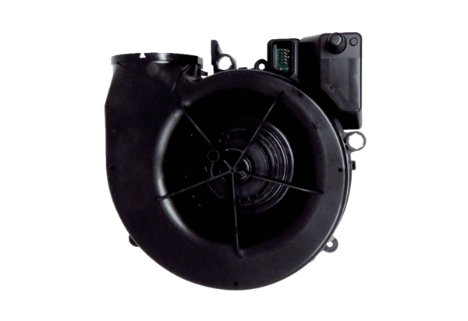Fans V WS 75Range: K
Article number: E156.0191.0002Manufacturer: MAICO

