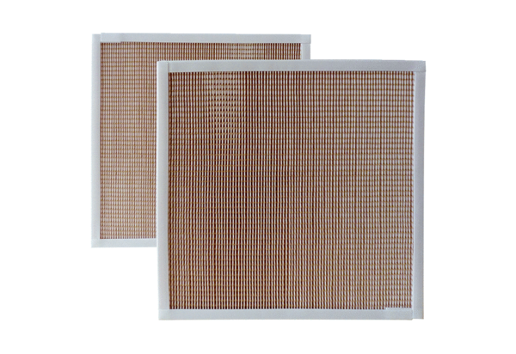Air filter, replacement RF 40-5Packing unit: 2 piecesRange: C
Article number: 0093.0879Manufacturer: MAICO

