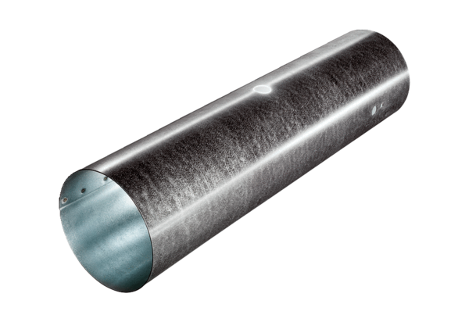Duct piece for servomotor MSR 150Packing unit: 1 pieceRange: C
Article number: 0092.0512Manufacturer: MAICO

