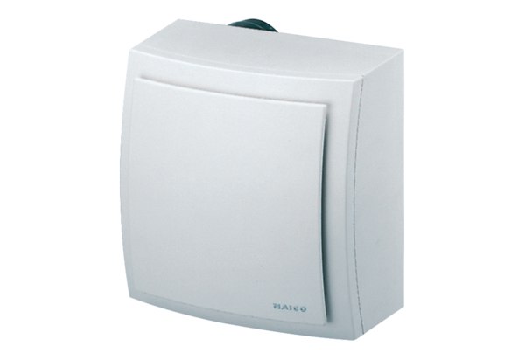Surface-mounted fan, fire protection ER-APB 60Packing unit: 1 pieceRange: B
Article number: 0084.0156Manufacturer: MAICO

