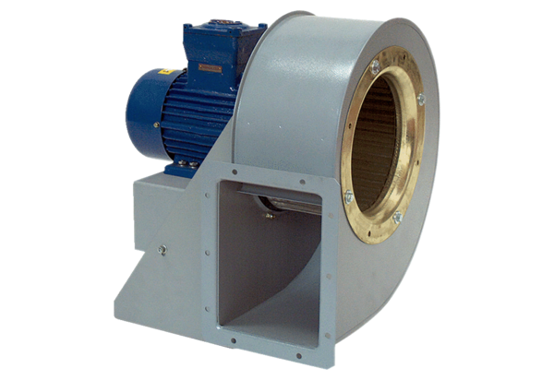Centrifugal blower GRM HD 45/8 ExPacking unit: 1 pieceRange: C
Article number: 0073.0419Manufacturer: MAICO

