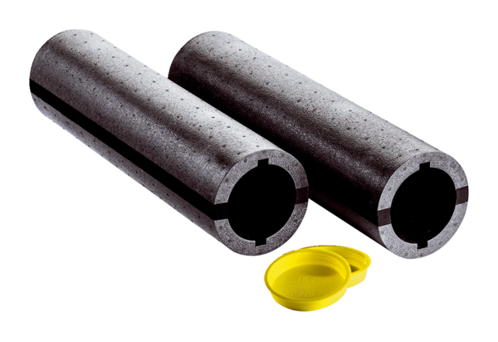shell installation kit Duo A-SRPacking unit: 1 pieceRange: K
Article number: 0095.0332Manufacturer: MAICO

