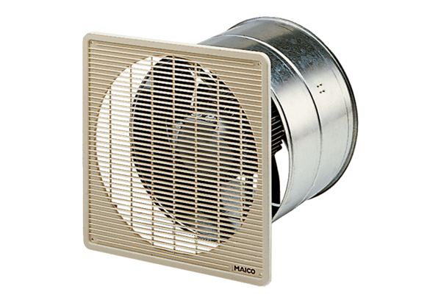DZF 45/6 BPacking unit: 1 pieceRange: C
Article number: 0085.0108Manufacturer: MAICO

