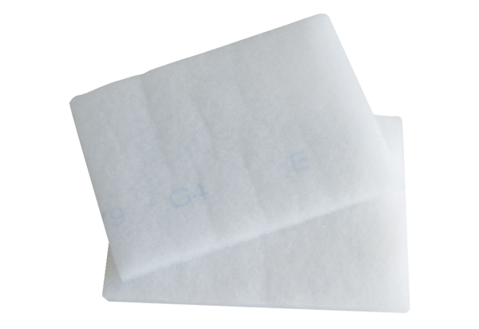Air filter, replacement EW-FPacking unit: 2 piecesRange: K
Article number: 0093.1231Manufacturer: MAICO

