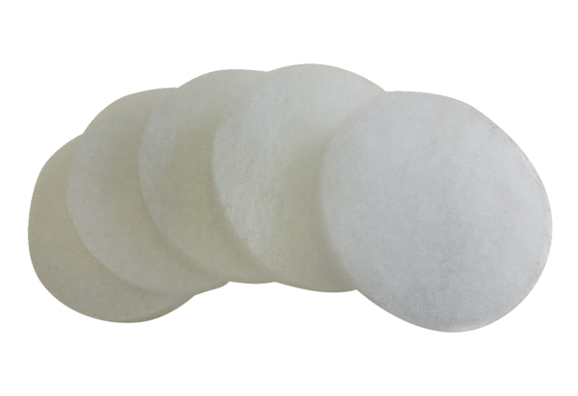Air filter, replacement ALDF 125/160 G3Packing unit: 5 piecesRange: B
Article number: 0093.0080Manufacturer: MAICO

