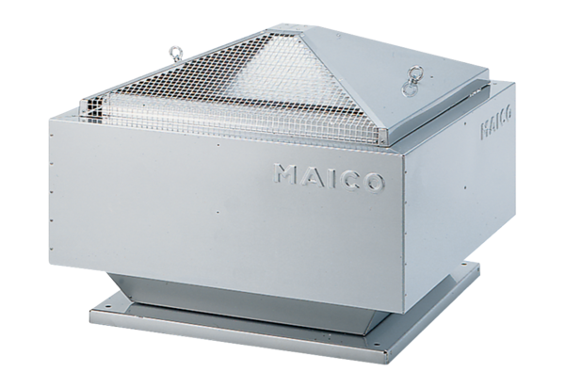Centrifugal roof fan MDR-VG 25 ECPacking unit: 1 pieceRange: E
Article number: 0087.0033Manufacturer: MAICO

