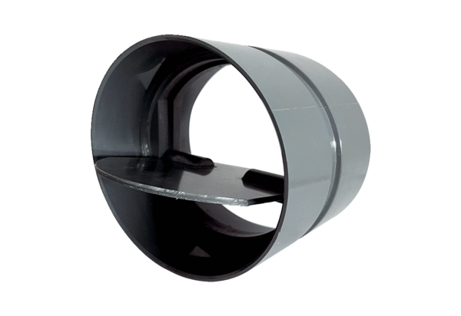Shutter VKKI 50Packing unit: 1 pieceRange: C
Article number: 0073.0479Manufacturer: MAICO

