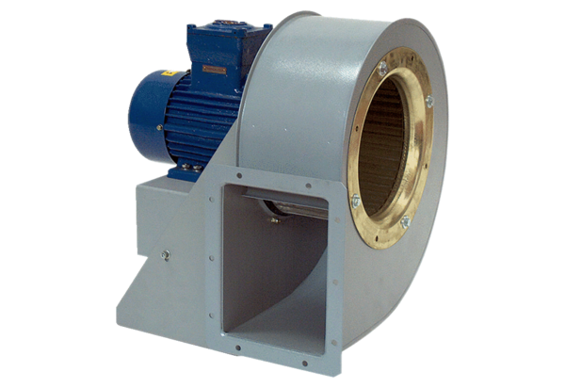Centrifugal blower GRM HD 22/2 ExPacking unit: 1 pieceRange: C
Article number: 0073.0398Manufacturer: MAICO

