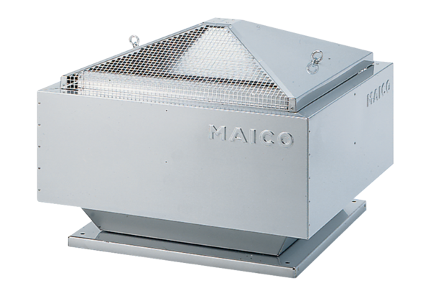Centrifugal roof fan MDR 40 ECPacking unit: 1 pieceRange: E
Article number: 0087.0029Manufacturer: MAICO

