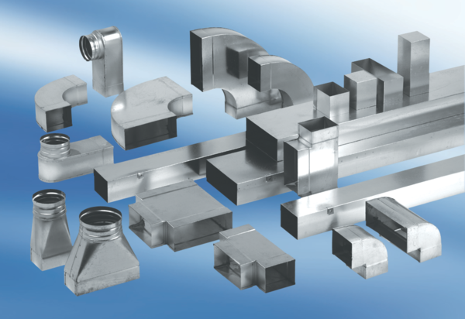Reducer, asymmetrical REDA80/200/80Packing unit: 1 pieceRange: K
Article number: 0055.0717Manufacturer: MAICO

