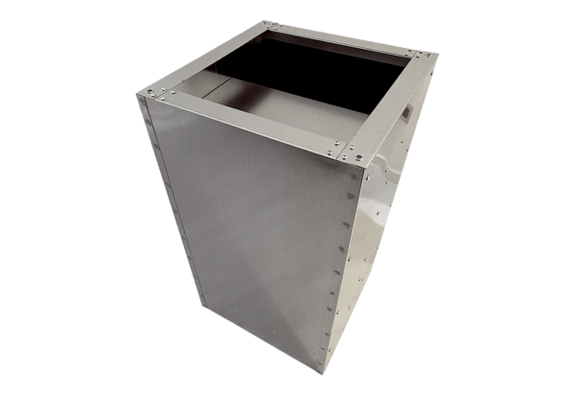Socket sound absorber SDI 40-45Packing unit: 1 pieceRange: C
Article number: 0073.0033Manufacturer: MAICO

