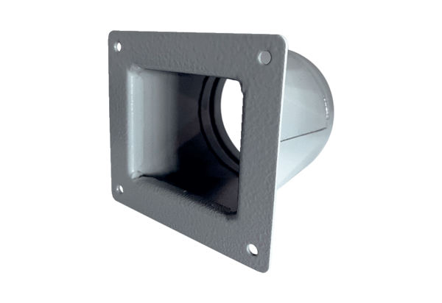Transition adapter URRI 18Packing unit: 1 pieceRange: C
Article number: 0073.0301Manufacturer: MAICO

