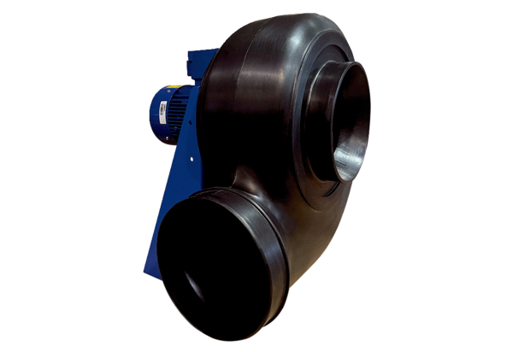Centrifugal blower GRK R 63/4 D ExPacking unit: 1 pieceRange: C
Article number: 0073.0460Manufacturer: MAICO

