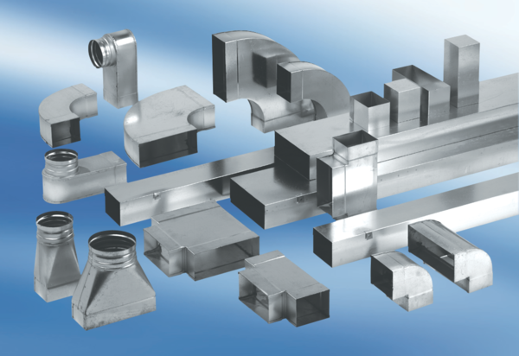Reducer, symmetrical REDS80/150/55Packing unit: 1 pieceRange: K
Article number: 0055.0700Manufacturer: MAICO

