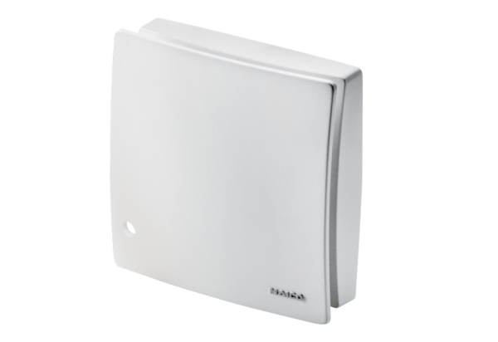Cover ABD ECA 100 ipro 2Range: A
Article number: E059.2022.9100Manufacturer: MAICO

