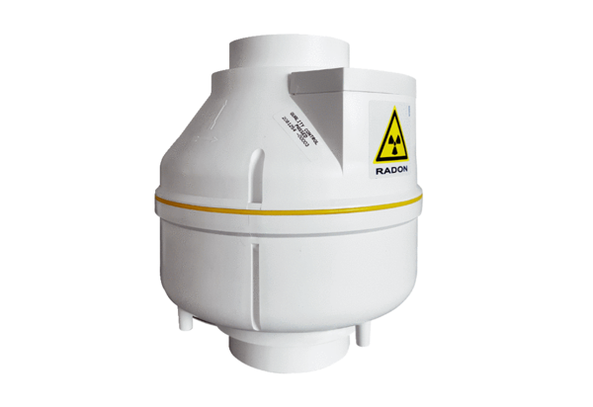Centrifugal duct fan RAS 15Packing unit: 1 pieceRange: C
Article number: 0080.0602Manufacturer: MAICO

