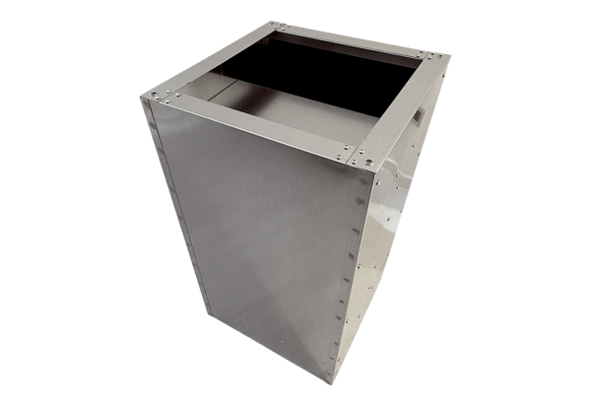Socket sound absorber SDI 35Packing unit: 1 pieceRange: C
Article number: 0073.0032Manufacturer: MAICO

