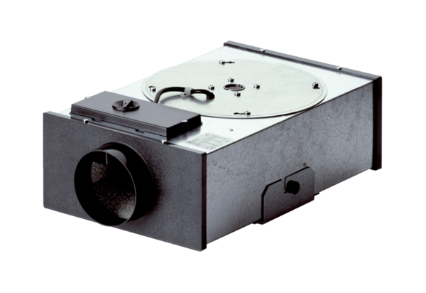Centrifugal flat box EFR 10 RPacking unit: 1 pieceRange: C
Article number: 0080.0571Manufacturer: MAICO

