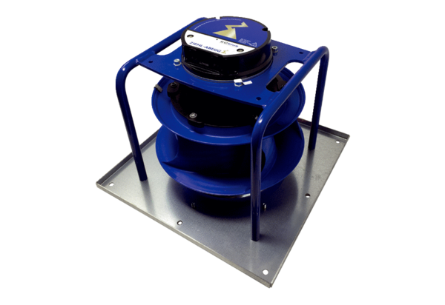Fans V CB 1200Packing unit: 1 pieceRange: L
Article number: E156.0205.0000Manufacturer: MAICO

