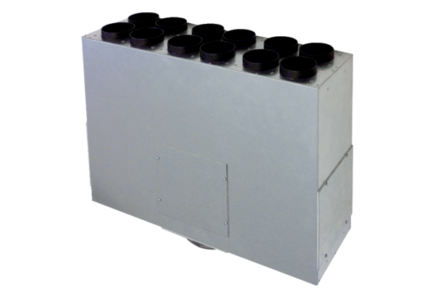Air distributor box made of sheet metal, 12-way MF-BV75-160-12Packing unit: 1 pieceRange: K
Article number: 0018.0528Manufacturer: MAICO

