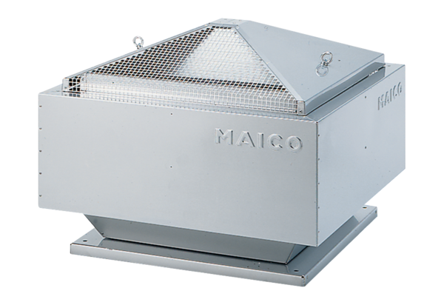Centrifugal roof fan ERD 35/6 BPacking unit: 1 pieceRange: C
Article number: 0087.0007Manufacturer: MAICO

