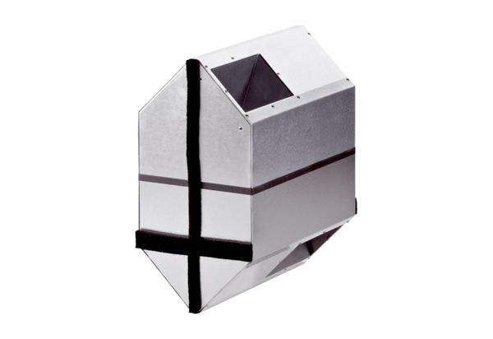Summer cassette WRSK 300-400Packing unit: 1 pieceRange: K
Article number: 0095.0152Manufacturer: MAICO

