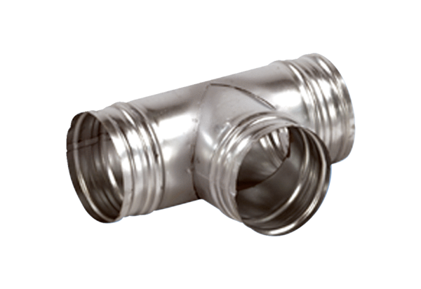90° branch AB 180-200Packing unit: 1 pieceRange: K
Article number: 0055.0380Manufacturer: MAICO

