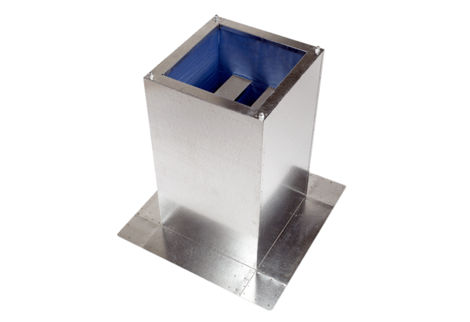Socket sound absorber SD 22Packing unit: 1 pieceRange: C
Article number: 0092.0338Manufacturer: MAICO

