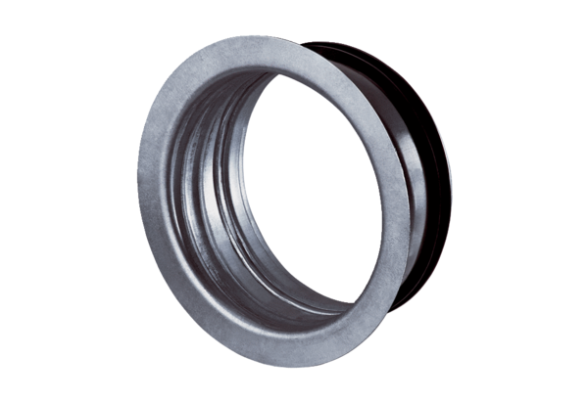Mounting frame for TFA/TFZ EBR-D 10Packing unit: 1 pieceRange: C
Article number: 0092.0493Manufacturer: MAICO

