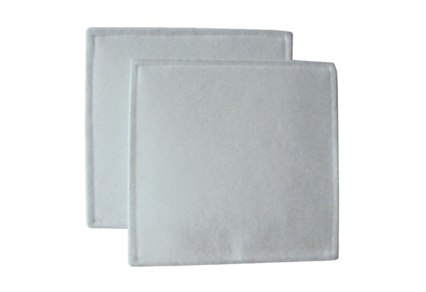Air filter, replacement RF 31Packing unit: 2 piecesRange: C
Article number: 0093.0695Manufacturer: MAICO

