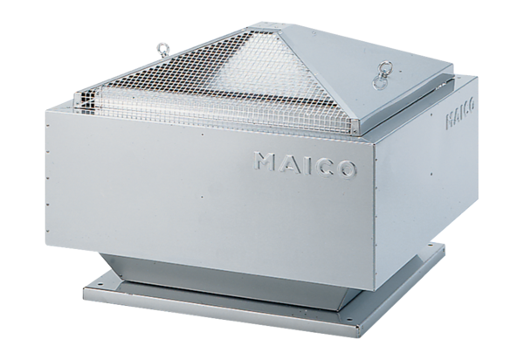Centrifugal roof fan MDR 45 ECPacking unit: 1 pieceRange: E
Article number: 0087.0030Manufacturer: MAICO

