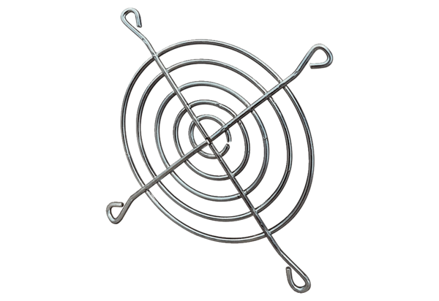Inlet protective grille SGEI 16-18Packing unit: 1 pieceRange: C
Article number: 0073.0287Manufacturer: MAICO

