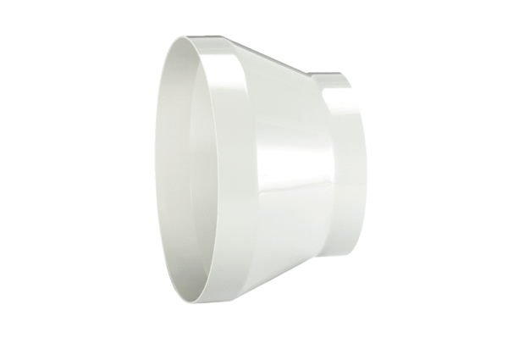Reducer REM 25/18Packing unit: 1 pieceRange: C
Article number: 0059.0637Manufacturer: MAICO

