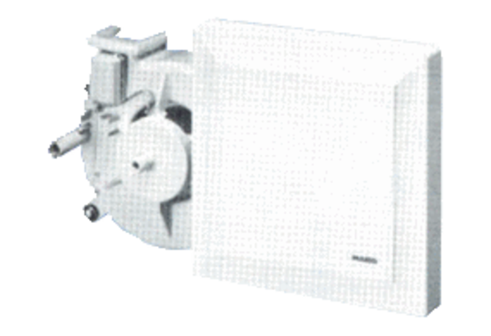Fan insert ER 17/100 FPacking unit: 1 pieceRange:
Article number: 0080.0741Manufacturer: MAICO

