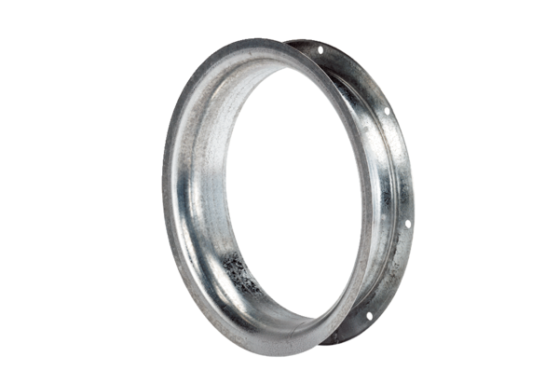Suction nozzle AD 20Packing unit: 1 pieceRange: C
Article number: 0180.0628Manufacturer: MAICO

