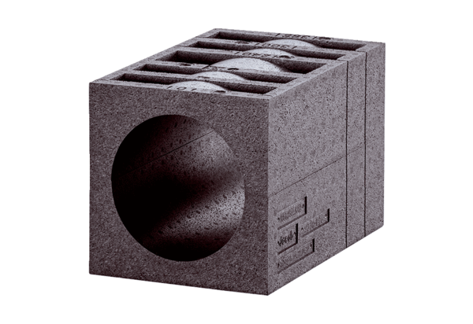Insulated wall block PP 45 MBPacking unit: 1 pieceRange: K
Article number: 0058.0143Manufacturer: MAICO

