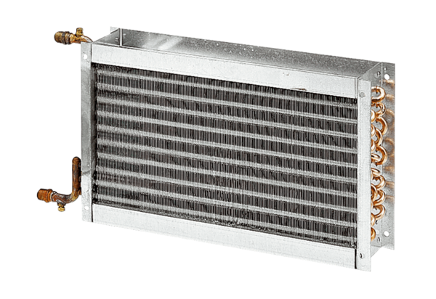Water air heater WHP 31-34Packing unit: 1 pieceRange: D
Article number: 0082.0114Manufacturer: MAICO

