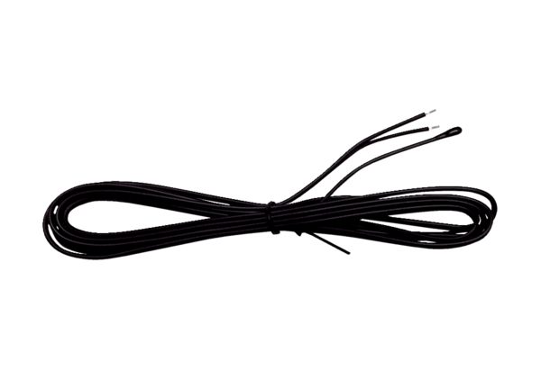Temperature sensor SE WS 75 TRange: K
Article number: E157.0165.0000Manufacturer: MAICO

