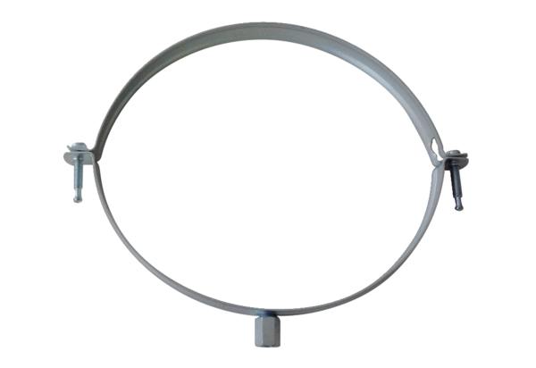Mounting clamp MT-LS125Packing unit: 1 pieceRange: K
Article number: 0018.0065Manufacturer: MAICO

