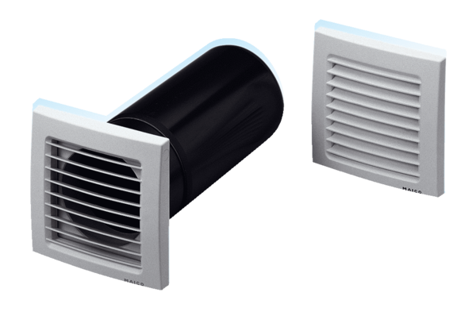Supply air element, uncontrolled ZE 15-1Packing unit: 1 pieceRange: D
Article number: 0152.0015Manufacturer: MAICO

