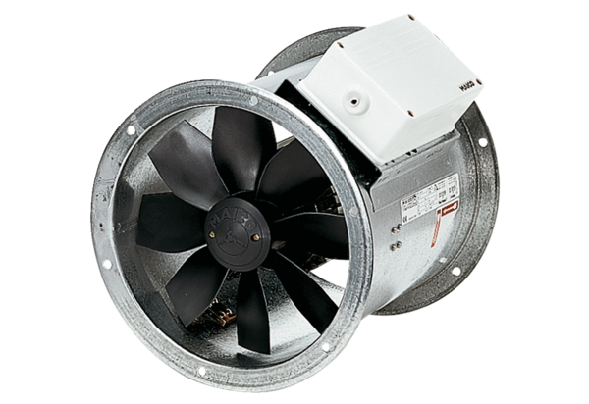Axial duct fan DZR 50/4 BPacking unit: 1 pieceRange: C
Article number: 0086.0062Manufacturer: MAICO

