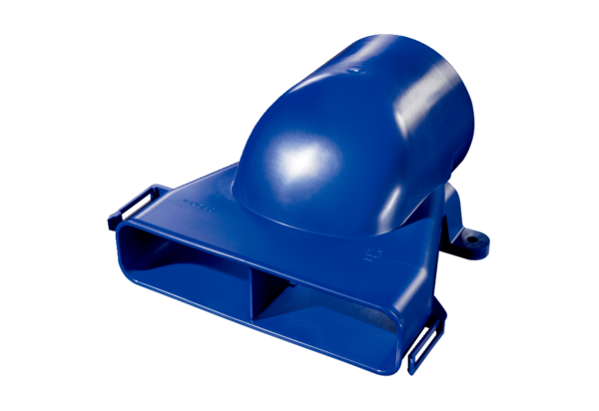Horizontal air distributor transition piece FFS-VTHÜPacking unit: 1 pieceRange: K
Article number: 0055.0901Manufacturer: MAICO

