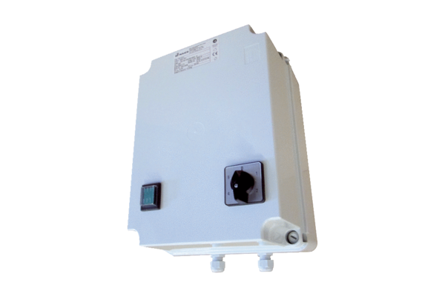5-step transformer TRE 10-2Packing unit: 1 pieceRange: C
Article number: 0157.0161Manufacturer: MAICO

