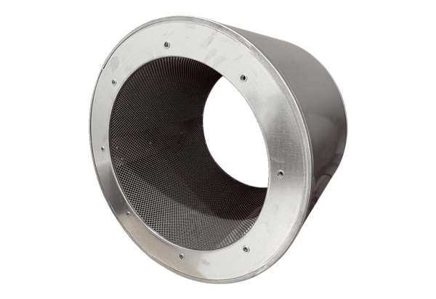Tubular sound absorber RSI 80/1000Packing unit: 1 pieceRange: C
Article number: 0073.0103Manufacturer: MAICO

