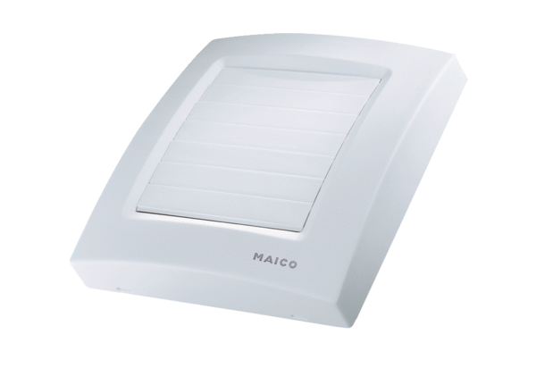Cover ABDK ECA 100 1Range: A
Article number: E059.1003.9002Manufacturer: MAICO

