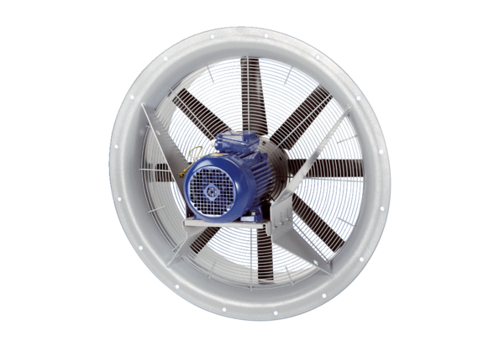Axial fan DAS 112/6Packing unit: 1 pieceRange: C
Article number: 0083.0864Manufacturer: MAICO

