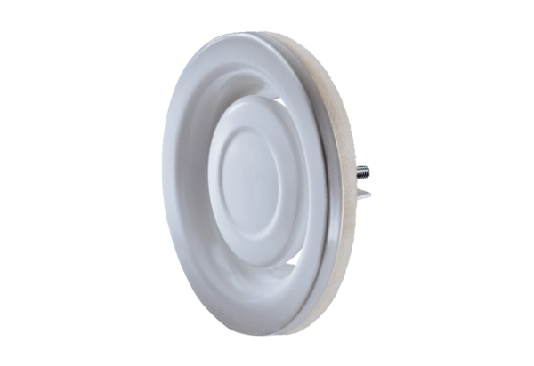Disk valve, metal TFA 16Packing unit: 1 pieceRange: C
Article number: 0151.0372Manufacturer: MAICO

