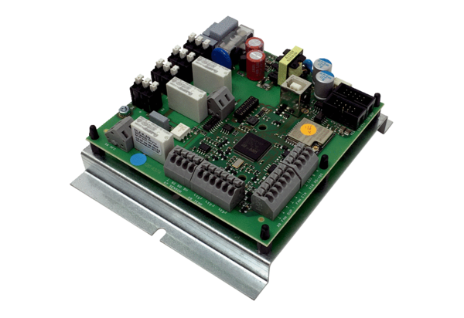Circuit board ST CB 1200Packing unit: 1 pieceRange: L
Article number: E093.1631.0000Manufacturer: MAICO

