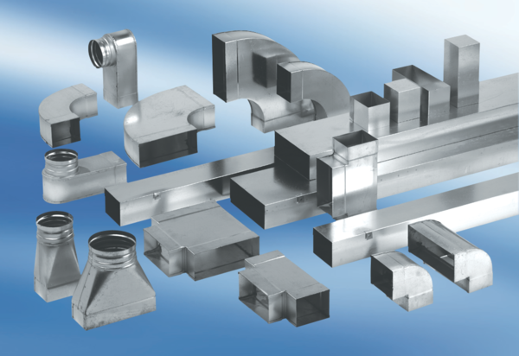Intermediate piece, symmetric USSN70/170/80Packing unit: 1 pieceRange: K
Article number: 0055.0679Manufacturer: MAICO

