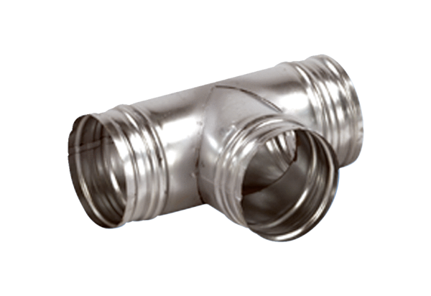90° branch AB 180-160Packing unit: 1 pieceRange: K
Article number: 0055.0378Manufacturer: MAICO

